**Career Plan Template**

**Format: Font: Verdana 12**

1. 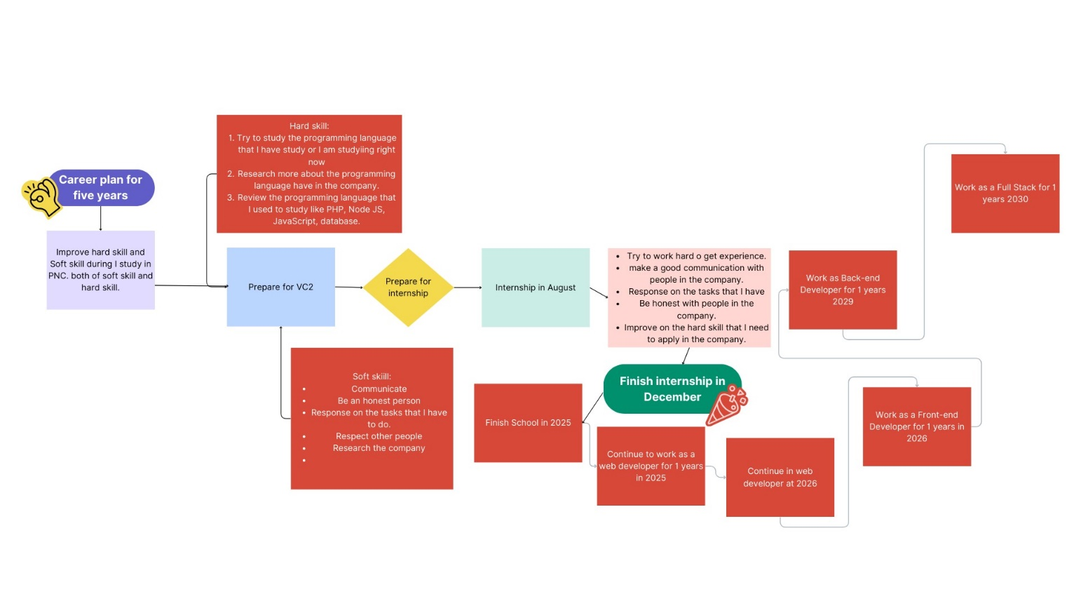**Draw your road map or your career plan in five years (30%)**
2. **Write reports with guidance questions (65%)**

|  |
| --- |
| 1. What is your professional goal in five years? 15% |
| In five years, I want to be a beck end developer, and finish bachelor’s degree, have a good job at company for myself and I can get my goal that I want to do when I was young, one more I can have my own business. |
| 1. What are your strengths and weaknesses? 10% |
| My strengths and weakness are:  +My strengths:   * + team work   + problem solving   + leadership   + Solidarity skill   + Responsible skill   + Respect skill   +My weakness:   * Decision * Communication skill * Confident * Control my feeling * Network * Presentation skill |
| 1. What kind of company do you want to work for? And why? 10% |
| I want to work in a solution company because it has a lot of project to do because have a lot of clients want to create their own website for their business, so I can improve my skill and have a lot of experience when I work as a team and have new project with new experiences also. |
| 1. How do you plan to upgrade yourself after PNC? 10% |
| I want to upgrade myself in technical skills and soft skill such as:   * + JavaScript   + PHP   + New language in that I have learnt nowadays (OOP, Node JS, and old language)   + Try to research new language   + Practice in the programming language that I am weakness * Improve in communication skill to make myself more confident in communicate more than now * Improve in time management because I think it is important when I have work in a company * Solidarity skill * Responsible skill to make it better than now * Leadership skill * Upgrade myself in presentation skill * Upgrade in English skill * Speaking skill * Team work * Make myself more confident on the thing that I have done * Can make decision by myself on the when I want to do something and it is good for me * Don’t waste myself with the thing that not good with me (example: Don’t waste time to play phone in free time) * To make myself have a lot of thing to do don’t make myself feel free * Improve in research skill * Practice more than now * Have schedule for myself |
| 1. What do you think about how the future of the IT job market evolves in Cambodia? 10% |
| I think the future of the IT job market evolves will be the best job in Cambodia because it have a lot of advantage in it to help in education and in business to make people more easier to manage their business, their education, etc…. and it will be the one of the best in the world. |
| 1. How do you adapt yourself to the evolving IT job market? 10% |
| * I want to adapt myself to the evolving IT job market such as: * Learn with new skill * Practice by myself * Keep learning * Update my portfolio * Try to get feedback from other people * Embrace change * Try to make communication with other people that work in a company * Be the first one to add my experiences * Access my current skills |

1. Attach one JD of your ideal job (5%)

* **Backend Developer**
* Job Description

• Collaborate with cross-functional teams to understand project requirements and contribute to the technical design of backend systems  
• Develop, test, and maintain server-side applications and APIs using industry-standard programming languages and frameworks  
• Design and implement scalable and secure database architectures  
• Implement data security and user authentication measures  
• Collaborate with Front-end developers to integrate user-facing elements with server-side logic  
• Build reusable code and libraries for future use  
• Stay updated on industry trends and emerging technologies, and propose improvements to current systems

* Job Requirements

• Proven experience as a Backend Developer with at least 1 year of professional experience.  
• Strong proficiency in server-side languages such as Node.js, Python, Ruby, etc.  
• Experience with backend frameworks (e.g., Express, Django, Spring).  
• Solid understanding of database management systems, including relational and NoSQL databases.  
• Knowledge of API design principles and RESTful web services.  
• Strong problem-solving and analytical skills.  
• Experience with containerization and orchestration tools (e.g., Docker, Kubernetes) is an advantage.  
• Familiarity with cloud platforms (e.g., AWS, Azure, Google Cloud) is an advantage.  
• Knowledge of micro services architecture is an advantage.  
• Good spoken English is an advantage